**Simple Explanation of Probability Density (or, Distribution) Function (PDF):**

Suppose, X is a random variable, being produced by a random process, with the Probability Density Function **denoted by *f*** (which is as always/ convention)

Then, the Probability that the randomly produced value of X is within the range of [a, b] is:

P { a ≤ X ≤ b} = , which is equal the area under the PDF function plot (plot of the function *f* ) from a to b

Obviously:  (why ???)

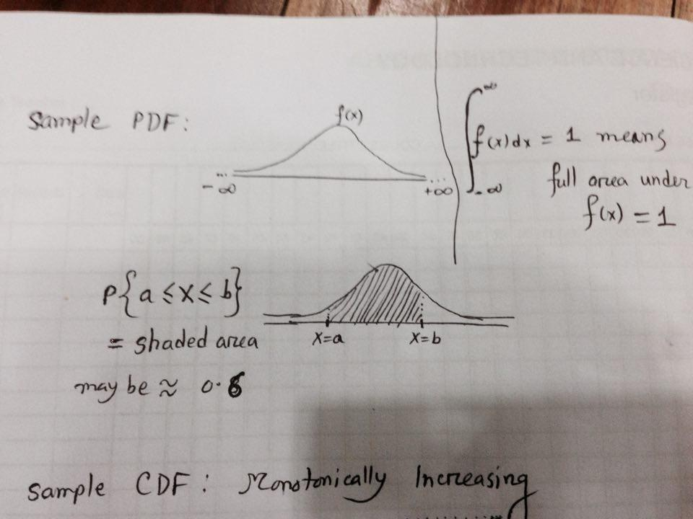

**as full area = 1.0**

**Simple Explanation of Cumulative Distribution Function (CDF): *** (always denoted by *F* ) \*\*\***

The Probability that the randomly produced X is less than or equal to a (that is, X ≤ a OR X is in the range of [–, a] is given by:

P { X ≤ a} = P { –≤ X ≤ a} =  = ***F* (a)**

Obviously, CDF is monotonically increasing (non-decreasing) function (… cumulative means what ???)

P { a ≤ X ≤ b } = F(b) – F(a)

P { X ≤ b} = F (b)

F () = 1.0

P { X ≥ b} = 1 – P { X ≤ b } = 1 – F(b)

See the pictures in the next page for insights …

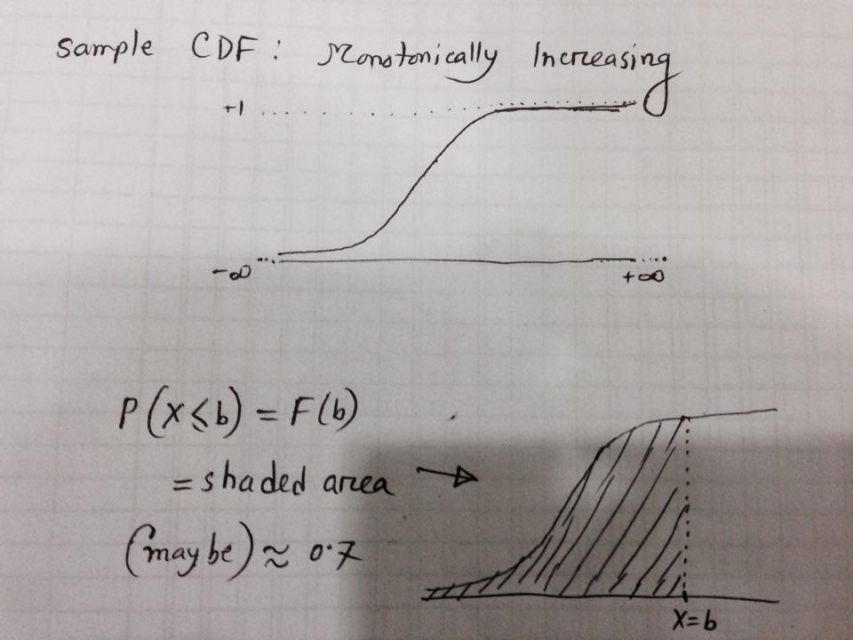

**as full area = 1.0**

